**Lesson 06 Lesson-End Project**

**Deploying MySQL RDS Using AWS**

**Project agenda:** To create and configure an RDS instance

**Description:** You must create an RDS database and deploy a Linux instance by creating it in EC2 and connecting an SSH client through EC2.

**Tools required:** AWS Management Console

**Prerequisites:** AWS account with CloudShell installed

**Expected deliverables:** RDS database with SSH client

Steps to be followed:

1. Create an RDS database
2. Launch an EC2 instance
3. Create security groups
4. Connect the terminal to SSH

**Step 1: Create an RDS instance**

1. In the AWS Management Console, search for and select **RDS**

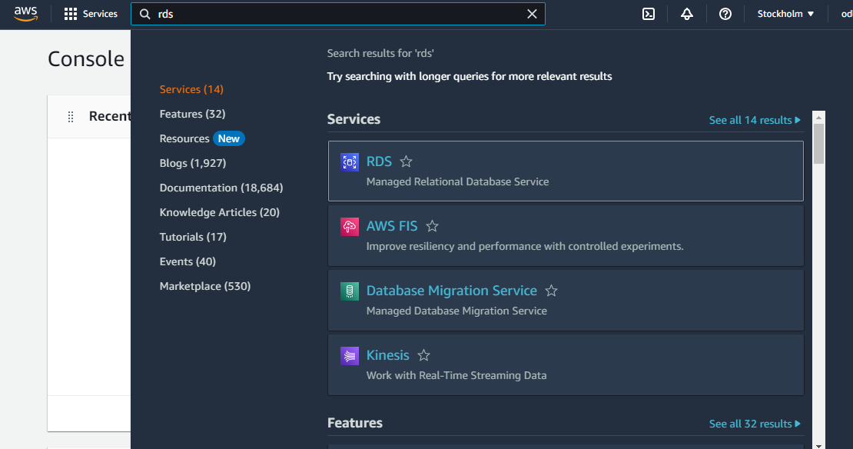

1. Click on **Create database**

1. Choose **Standard create** and select **MySQL**

1. Select the **MySQL 8.0.31** option and choose the **Free tier** box

1. Select **us-east-1a** as the **Availability Zone**

1. Click on **Create database**

You must wait a few minutes to complete the database.

1. Once the database is successfully created, access the database details by clicking on it

1. After the creation of the database, take note of the **Endpoint**

**Step 2: Launch an EC2 instance**

1. Navigate to the AWS Management Console, click on **EC2**

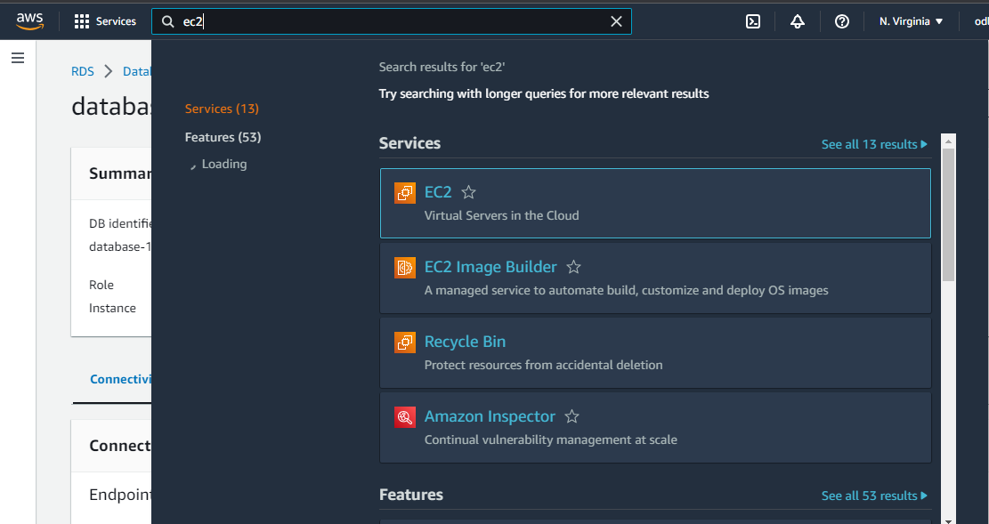

1. Click on **Instances** and select **Launch instances**

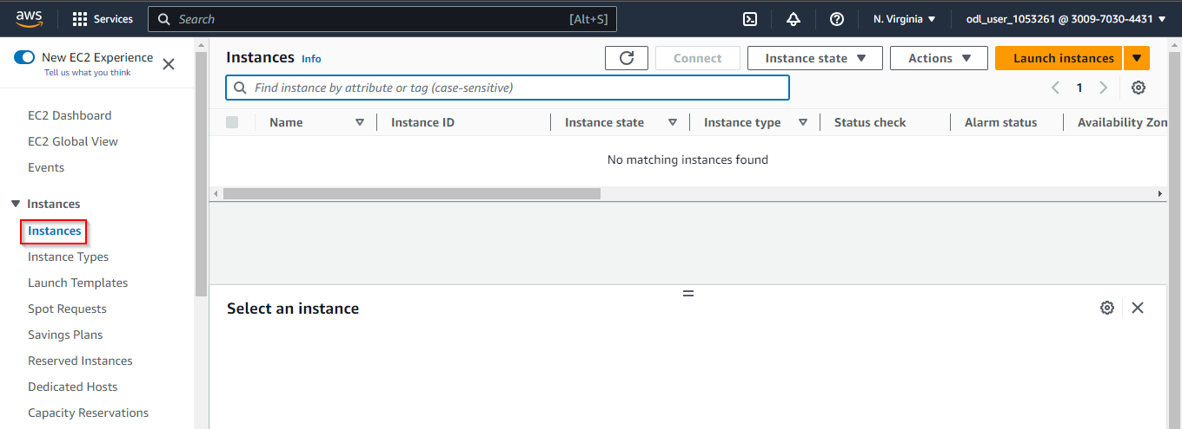

1. Provide an instance name and choose the **Amazon Linux** option

1. Select the **Amazon Machine Image (AMI)** with kernel version 5.10

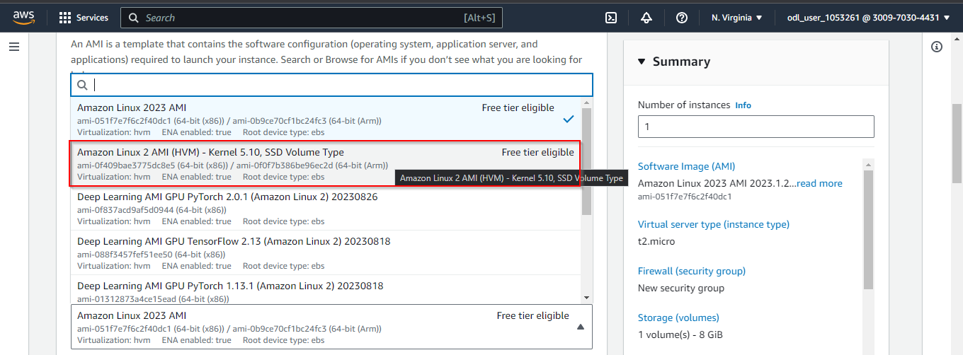

1. Choose the **t2.micro** instance type

1. Click on **Create new key pair**

1. Enter the **Key pair name** as **mykeypair** andclick on **Create key pair**

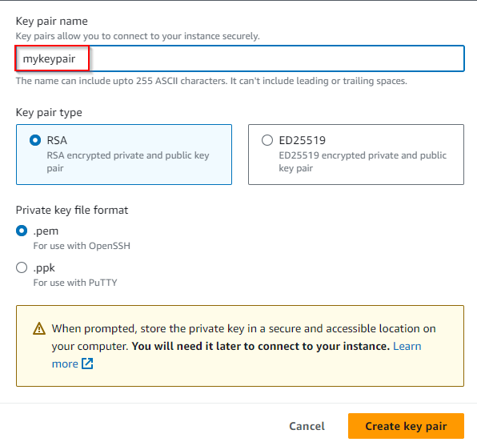

1. In the **Network settings**, select **us-east-1a** as the Subnet

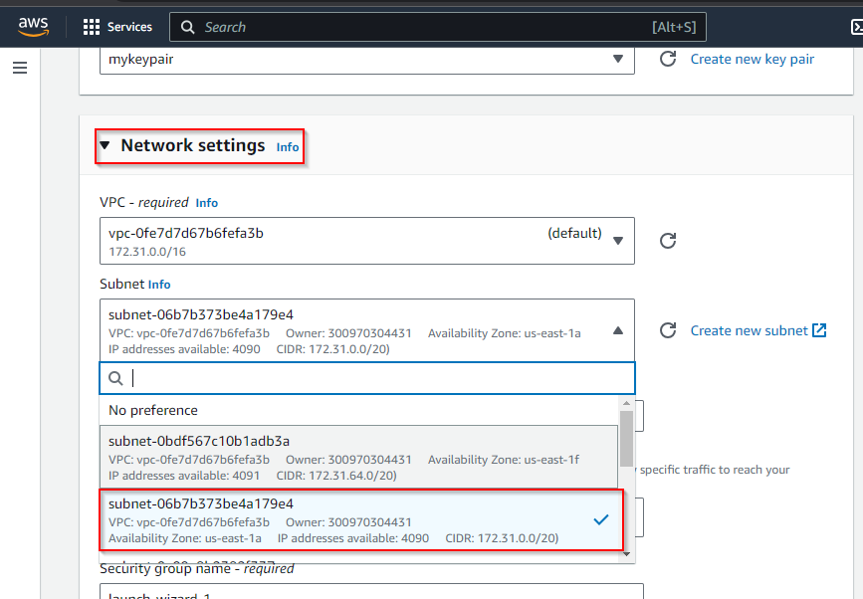

1. Click on **Launch instance**

**Step 3: Create security groups**

1. Navigate to **RDS Databases** and access the settings **icon**

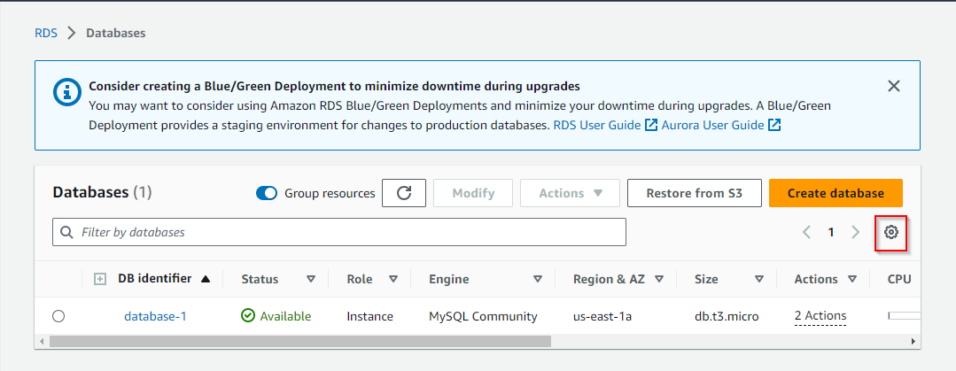

1. Change the resources per page to **20**

1. Enable **Security groups** and click on **Continue**

1. Click on the default security group and navigate to **Inbound rules**

1. Click on **Edit inbound** **rules**

1. **Delete** the default inbound rules and save the changes

1. Now, click on **Add rule**

1. Search and select **MYSQL/Aurora** and click on **Save rules**

1. Select Source as **Anywhere IPv4** andclick on **Save rules**

Inbound Security groups are created successfully.

**Step 4: Connect the terminal to SSH**

1. Navigate to **EC2** in the console, select **Instance,** and click **Connect**

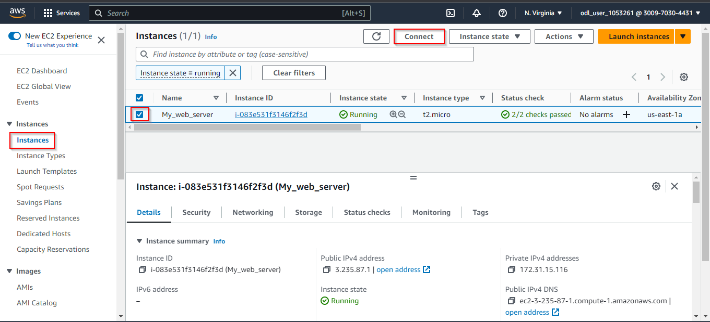

1. Enter the username as **test** and click **Connect**

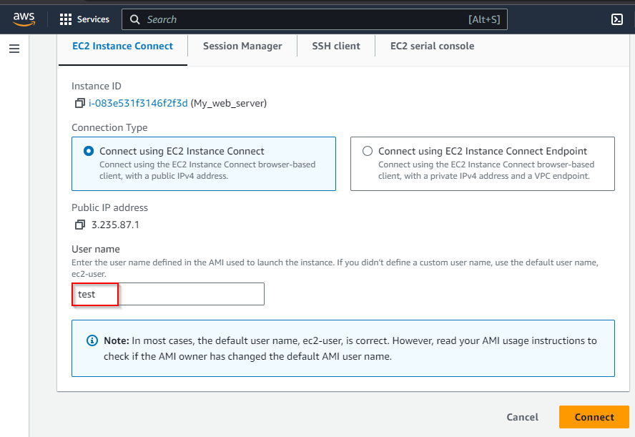

1. Enter the command below to install MySQLand type **y** to install:

**sudo su**

**sudo yum install mysql**

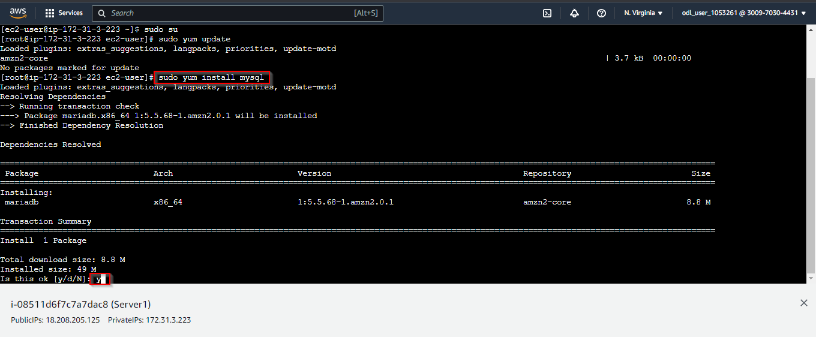

1. Use the command below to connect to the MySQL server (replace placeholders with actual values):

**mysql -h <YOUR RDS instance endpoint> -P 3306 -u <USERNAME of your RDS Instance> -p**

**ex: mysql -h database-1.cb1z111hlxj6.us-east-1.rds.amazonaws.com -P 3306 -u admin -p**

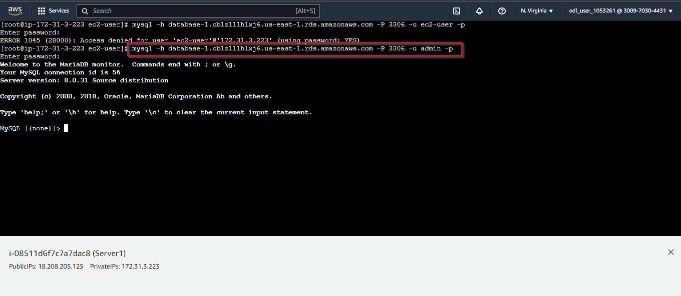

The MySQL database has been accessed successfully.

By following these steps, you have successfully set up a database, launched an EC2 instance, configured security groups, and established an SSH terminal connection.